

Do you want to be a Nurse Practitioner, or are you currently studying in preparation for Nurse Practitioner registration?
As you begin your post graduate educational preparation, or at the point you think you would like to progress to becoming a nurse practitioner, there are some important things to consider:

- What is your proposed area of practice?
- Have you taken the right papers?
- Is there a need for an advanced nursing resource in this area of practice?
- Where will you fit in the continuum of health care providers?

Remember, Nurse Practitioner is the scope; Area of Practice is the specialty in which you wish to practice, e.g. mental health or primary health care.

Steps to Becoming a Nurse Practitioner:
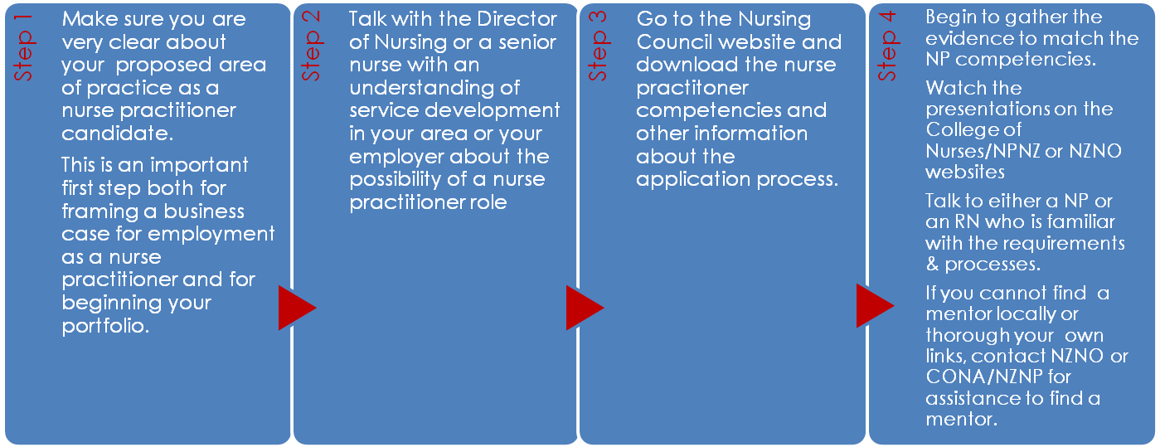

Action Points:
1: Discuss your plans with your nurse director/nurse leader or manager and find out whether there is a need for an advanced nursing resource in your proposed area of practice
- Talk to your director of nursing/nurse leader early on in your planning. These leaders will be able to review and discuss your area of practice in relation to future development needs of NP roles. They will be able to talk about the organisations strategic plan and whether there would be NP role development within the near future. If they see a need for the role they may also be able to support your case in the appropriate forums, as funding of NP roles can be a barrier. There may be an NP champion in your service/area who you can talk to. If there are NPs working in your service/area talk to them about their role development.
- You can’t guarantee a job unless you have prepared the way, and you can’t do that in isolation, you must include people who can help with service delivery, funding strategies, business cases, job descriptions and team development. Becoming an NP is only one aspect of increasing the NP workforce, the workforce must also change shape to accommodate and embrace this new opportunity.

2: Clearly understand the NP scope and be clear about your Area of Practice.
- Nurse Practitioner is the scope; Area of Practice is the specialty you wish to practice in e.g. mental health, primary health care, older persons’ health. Think broadly when deciding your Area of Practice. Defining the area too narrowly may be restrictive in the longer term as NP practice develops and roles change. Seek advice around this issue as there is a definite trend in NZ towards broader roles.
- The Nursing Council of New Zealand has information about the NP scope and areas of practice on its website http://nursingcouncil.org.nz/index.php/Nurses/Scopes-of-practice/Nurse-practitioner

3: Develop some understanding of business models and preparing business cases/proposals.
- You will possibly need some support from your nurse leader and/or manager to prepare a business case for the nurse practitioner position.
- NPs work towards health gain to address and reduce inequalities and inequities in health. The role of the NP is centred on patient and population needs and improving health outcomes. Ensure you can clearly articulate how you, in an NP role will address this.

Visit these websites for more information:
www.nurse.org.nz
www.nzno.org.nz
www.nursingcouncil.org.nz
http://www.nurse.org.nz/npnz-nurse-practitioners-nz.html

